May 20, 2015

https://www.facebook.com/TheHungryChronicles

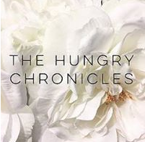

Posted: 05/20/2015

By Ane

Have you guys heard of @OrganoGold Coffee?

It's infused with Ganoderma, a mushroom extract used for thousands of years in traditional Asian medicine for its antioxidant and immune support. Add to that the benefits of coffee itself like improved memory, circulation, plus the boost you get from caffeine, and having a cup of coffee in the morning seems more like you're doing yourself a solid rather than giving yourself a "fix" just to wake up . You can check out their Instagram page and click the link in their profile to find out more.

#‎delicious‬ #‎coffee‬ #‎caffeine‬ #‎healthy‬ #‎instayum‬ #‎instagood‬ #‎foodblogger‬ #‎HungryGirlAustin‬ #‎vsco‬ #‎vcsocam‬ #‎yummy‬ #‎wired‬ #‎java‬ #‎ganoderma‬

