http://www.fitandfabliving.com/fitness/fitness-tips/11455-organo-gold-coffee-with-ganoderma

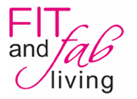

By Ashley Kolpak

When I first came across Organo Gold, I was definitely puzzled. A coffee drink that aids with exercise? I'd never tried one before. Naturally, the caffeine helps with endurance and stamina in everyday workouts. But the real pinch hitter here is ganoderma.

Ganoderma is an extract of the reishi mushroom. Reishi are commonly used in Eastern medicine and is known as "The King of Herbs". Among it's many benefits, ganoderma aids in boosting the immune system and fights fatigue. As always, only take the recommended dose or serving size for the best results. Click here to learn more about the benefits of ganoderma!

