April 23, 2015

http://espn.go.com/boxing/story/_/id/12749483/companies-purchasing-rights-appear-trunks-floyd-mayweather-manny-pacquiao-fight

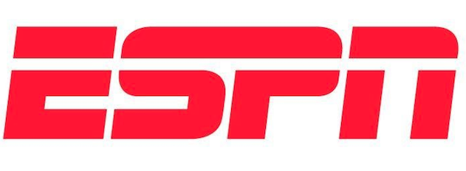

Companies purchase space on Floyd Mayweather, Manny Pacquiao trunks
Posted: 4/23/2015

By Darren Rovell

Manny Pacquiao and Floyd Mayweather Jr. will be human billboards for their May 2 fight, and space is quickly filling up.

Daily fantasy sports company FanDuel said Thursday afternoon it bought the rights to have its name on the belt line of Mayweather's trunks.

The deal includes branding on Mayweather's team throughout the fight weekend and during the fight and comes with six tickets, with a face value of $10,000 each, that the company will award to the winners of three fantasy contests on its site over the next three days. FanDuel spokeswoman Justine Sacco said those winners will also get free hotel and airfare and a meet-and-greet with Mayweather.

Pacquiao adviser Michael Koncz said the boxer will wear many of the same trunk sponsors he featured the last time he was in the ring, including Nike, Cafe Puro and Air Asia. Pacquiao is also expected to wear a headband with a Motolite batteries logo on it and a shirt at the weigh-in promoting Organo Gold Coffee.

ESPN.com's Dan Rafael reported earlier this month that Tecate spent $5.6 million to be the official beer of the fight and will get center-ring branding as part of the package.

Some brands will get into the ring for free. One guarantee is Mayweather's TMT brand, which stands for The Money Team. But there could be others. Mayweather has been wearing Reebok shoes in training for this fight even though the company is not compensating him.

"While we are not official partners at present, Floyd has been a longtime friend of the brand and he has worn Reebok footwear in the ring for years," said Todd Krinsky, Reebok's global vice president of classics and combat training.

